Company Merger

Infrastructure Integration Project

Deliverable 5 : Closing: User Interface Design, Program design and System Implementation.

December 4th 2019

IS 436

Muhammad Hamza - Project Manager

[ham15@umbc.edu](mailto:ham15@umbc.edu)

443-889-8146

Siril Pattammady - Systems Developer

[psiril1@umbc.edu](mailto:psiril1@umbc.edu)

301-323-3245

Josh Johnson - Systems Analyst

[jjohn3@umbc.edu](mailto:jjohn3@umbc.edu)

240-786-8420

Khadija Shafiq - Business Analyst

[kshafiq1@umbc.edu](mailto:kshafiq1@umbc.edu)

410-508-5849

Jay Patel - Network Engineer

[jpa2@umbc.edu](mailto:jpa2@umbc.edu)

410-428-8465

Shaikha Al Shamsi - Requirement Analyst

[shaikha1@umbc.edu](mailto:shaikha1@umbc.edu)

443-515-9765

1. **User Interface Design**

**1) Develop interface design prototypes for 3 most important screens, reports, or forms of your choosing.  
You can use Visio, any web page design tool, Visual Basic or any other case tool. These are only prototypes. You will not program or implement any functionality.**

1. **Home Page**

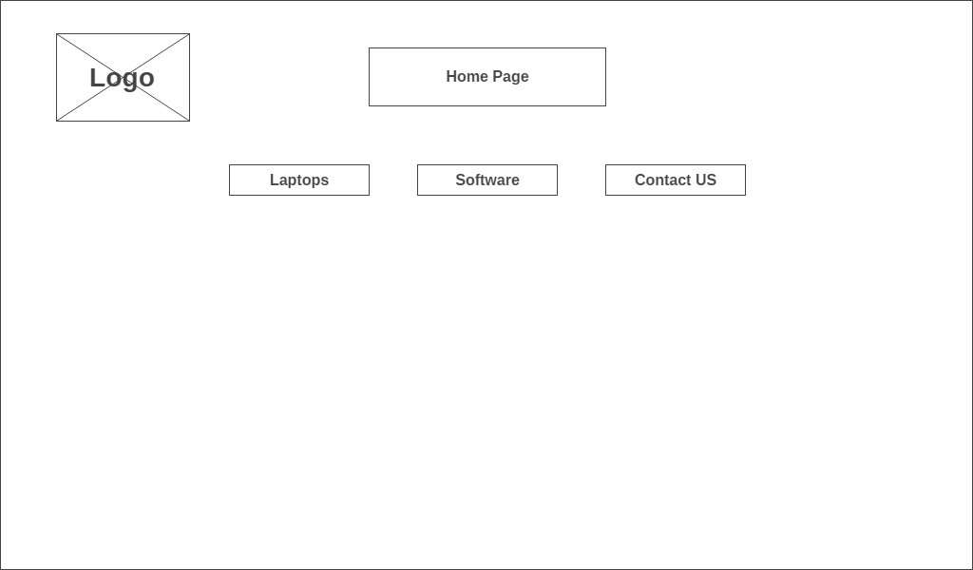

1. **Laptop Request Page**

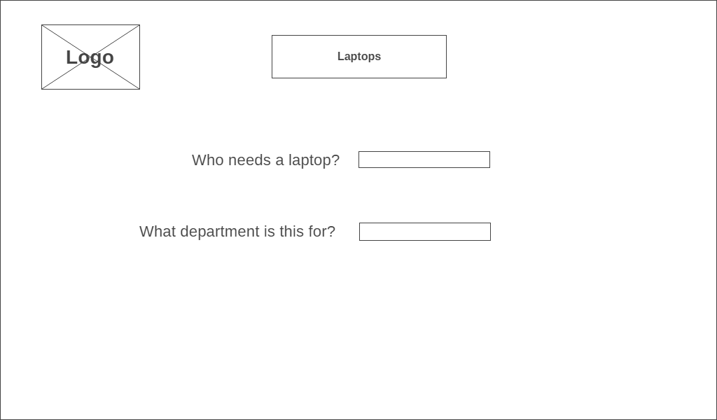

1. **Software Request Page**

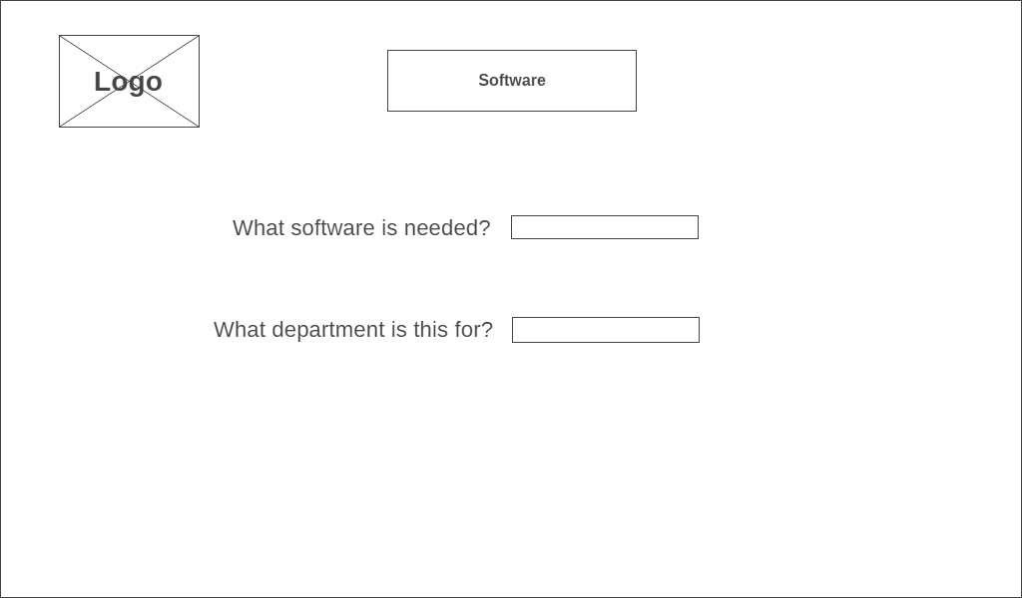

1. **Contact/Service Page**

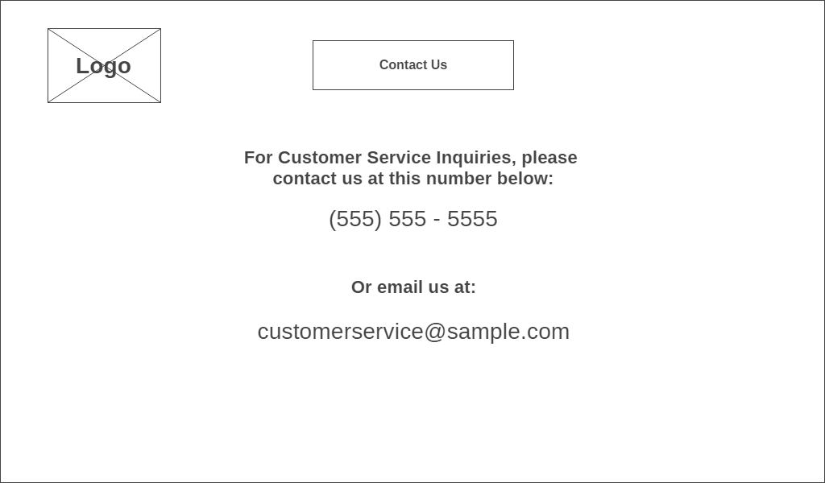

**2) Discuss the interface standards that you would like to follow and make decisions.**

The interface standards are the basic design elements that are common across the individual screens, forms, and reports within the system. Depending on the application, there may be several sets of interface standards for different parts of the system. The standards serve as the touchstone ensuring that the interfaces are consistent across the system. The Standards that we would like to follow and make decisions are:

#### **Interface Metaphor**

The fundamental [interface metaphor](https://jigsaw.vitalsource.com/books/9781119496328/epub/OPS/c09.xhtml#c09-term-0041) is a concept from the real world that is used as a model for the information system. The metaphor helps the user to understand the system and enables the user to predict what features the interface might provide, even without actually using the system.

**Interface Objects and Actions**

The major [interface objects](https://jigsaw.vitalsource.com/books/9781119496328/epub/OPS/c09.xhtml#c09-term-0042) are the fundamental building blocks of the system, such as the entities and data stores. The [interface actions](https://jigsaw.vitalsource.com/books/9781119496328/epub/OPS/c09.xhtml#c09-term-0043) are common commands that will be employed by the users. It is important to use terminology that fits the users' expectations consistently throughout the system.

#### **Interface Icons**

The interface objects and actions and also their status (e.g., deleted, error), may be represented by [interface icons](https://jigsaw.vitalsource.com/books/9781119496328/epub/OPS/c09.xhtml#c09-term-0044). Icons are small pictures that will appear on command buttons as well as in forms and reports to highlight important information.

**Interface Templates**

The [interface template](https://jigsaw.vitalsource.com/books/9781119496328/epub/OPS/c09.xhtml#c09-term-0045) defines the general appearance of all interface components in the information system (screens, forms, and reports). The template design specifies the basic layout of the screens (e.g., where the navigation area(s), status area, and form/report area(s) are placed), the color scheme(s) that will be applied, and the font styles and sizes to be used. It defines whether windows will replace one another on the screen or will cascade on top of each other. In short, the template draws together all the other major interface design elements: metaphors, objects, actions, and icons. Templates help ensure user interface consistency throughout the system.

1. **Program Design  
   Convert your prototype design into functional program. Create a program using html or any other programming languages. You don’t need to create actual database, but should include your database table structure if your interface interacts with the database table.**

**Laptop Request**

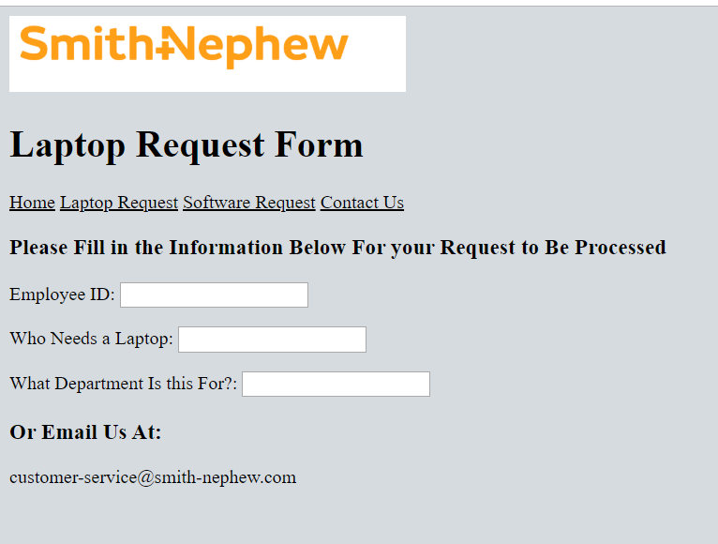

**Software Request**

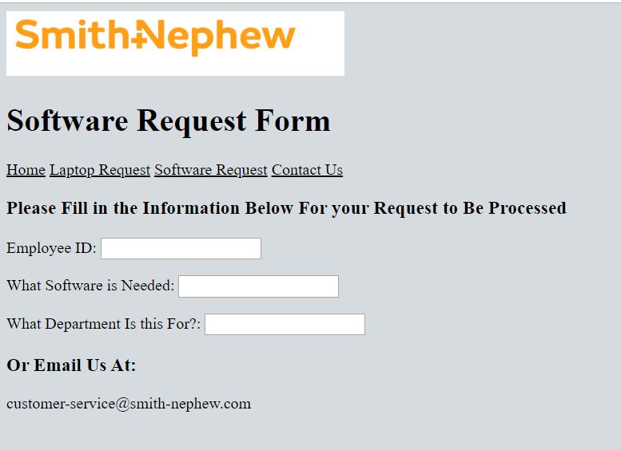

**Contact Page**

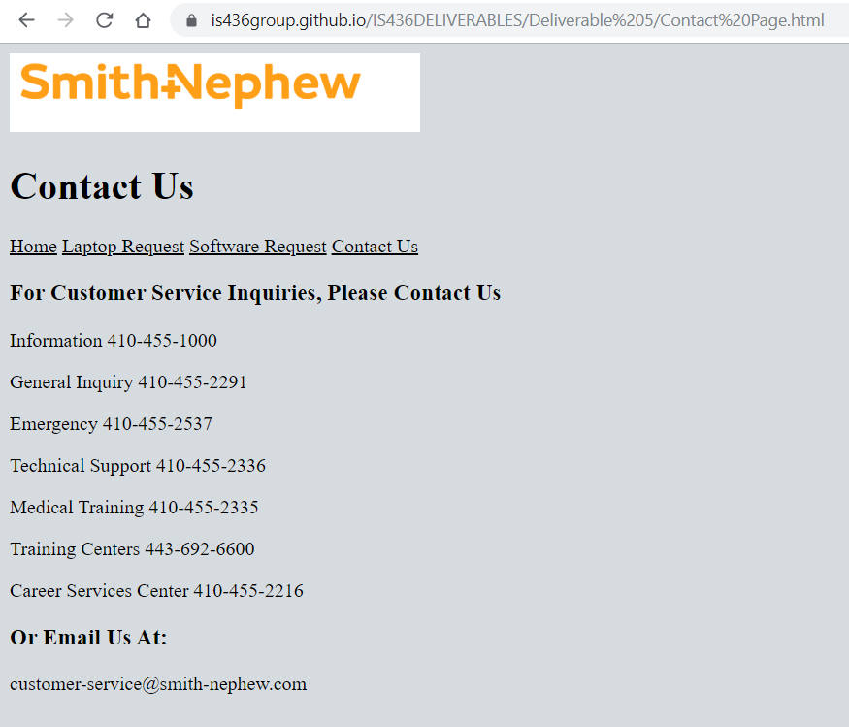

1. **System Implementation**

**1) Upload your programming code into Github. -- UPLOADED**

**2) Discuss the system requirements in order to implement your project (i.e. software, hardware, platform Etc.**

In order to implement our project, all that is needed is a web platform in order to access the HTML site. With this site in place any user with the correlating link will be able to send a request or be able to contact. A higher level requirement to be implemented will be once the merger database is created between Smith and Nephew and Osiris, then all the requests can be stored into the database platform for all the requests to be noted and completed in a frame amount of time.

1. **Updated project plan**
2. **Kanban board.**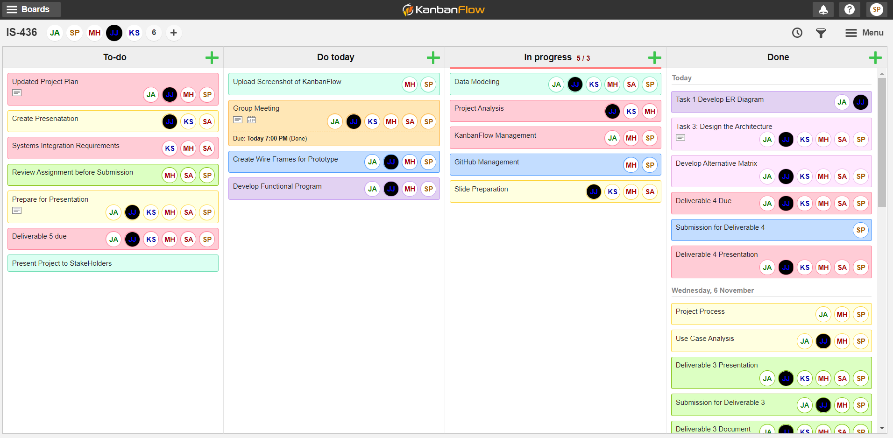
3. **Explain your team experiences throughout SDLC process. (i.e. rewarding, challenging and how did you solve the challenges as a team)**

The Overall team experience was great. With so many people working on a project together, there can be disagreements and differences in a team that can have a negative impact on the project and work environment but the tasks were divided equally among all the team members and the project went on rather smoothly. The project itself was challenging and and the process was pretty lengthy, but each deliverable had something new to learn from. The biggest challenge we faced was to arrange meeting times within the group as every group member had different class schedules, we overcame this problem by using GroupMe and Google docs to make it easy for all the group members to work on the project without having face to face meetings. The Project manager made sure that every team member was on the same page with the process.

1. **Demo your completed application to the stakeholders.**

Demo to be completed Friday with stakeholders. Arranged with Project Manager and Systems Developer.